TASK | Oil used to operate the hydraulics on lifting equipment
LOCATION OF USE | Workshop and field engineers |  | Assessment  No |  | 021
PRODUCT NAME | Pirtek Hydraulic Oil 46
DESCRIPTION OF SUBSTANCE | Hydraulic fluid
MANUFACTURER | Pirtek UK Ltd
MANUFACTURERS CONTACT | 199 The Vale  Acton  London  W3 7QS  Tel: 0208 749 8444
ASSESSOR | Martin Monaghan CMIOSH |  | Date |  | 04 12 25
TITLE | Health and Safety Consultant |  | Review by |  | 04 12 27
Personnel Performing Task  (Please list below)  Technicians/ Fitters/ Workshop Operatives |  | Time Spent  (Minutes/day)  As and when required, amounting to a few minutes per day | Training Given 
 |  |  | Yes

MSDS Revision Date | Hazard Statement
29 03 2016 Rev:1 | None classified

Assessment to be conducted in Association with Hazard Data Sheets, a full current copy of which must be attached to this assessment.

Please denote the hazardous properties of the substances used in the task with a 

NEW INTERNATIONAL GLOBALLY HARMONISED HAZARD SYMBOLS
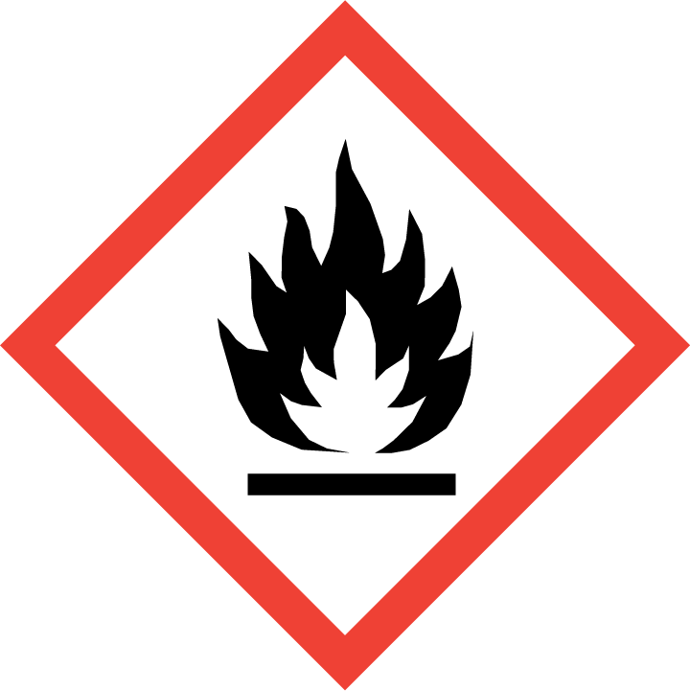 | 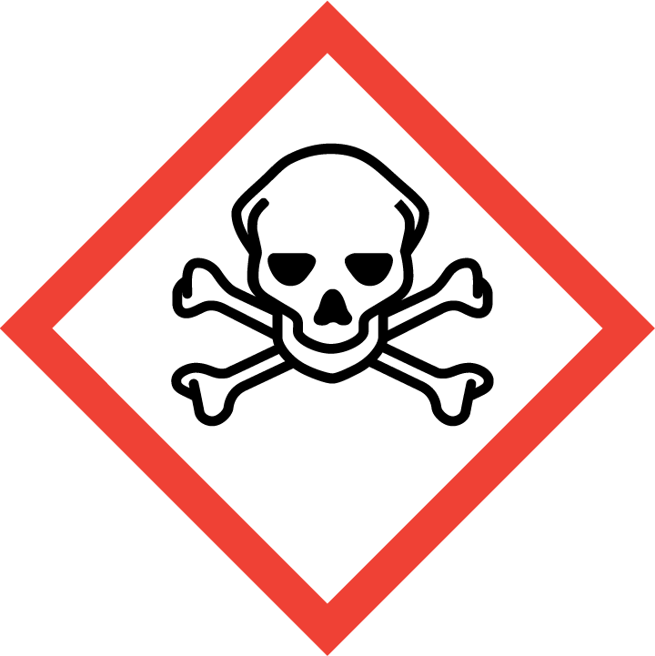 | 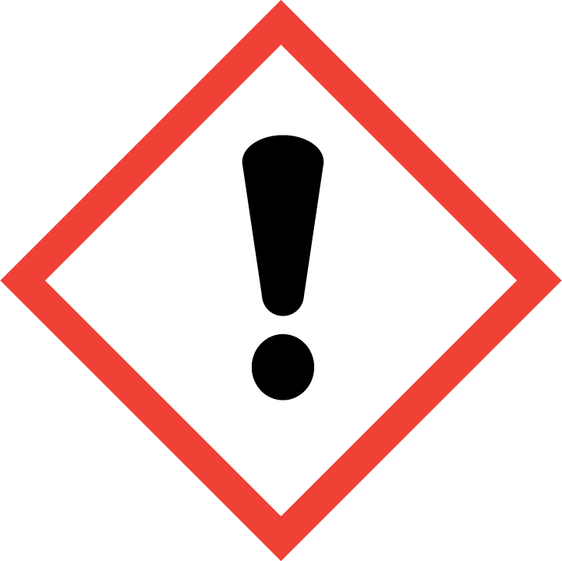 | 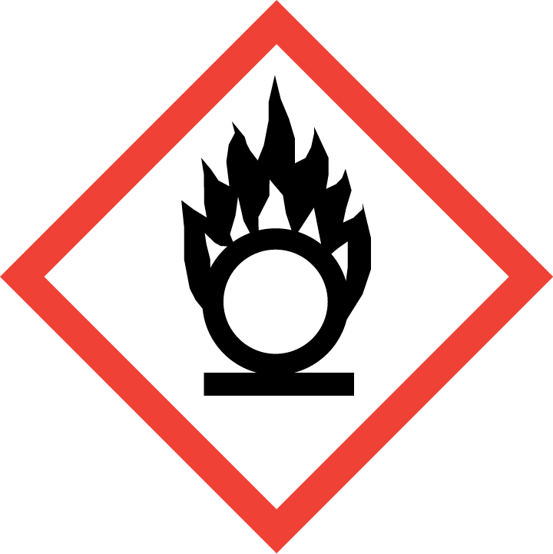 | 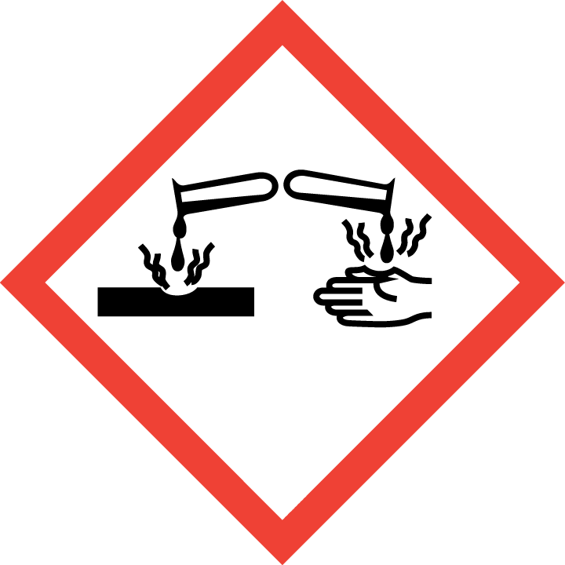 | 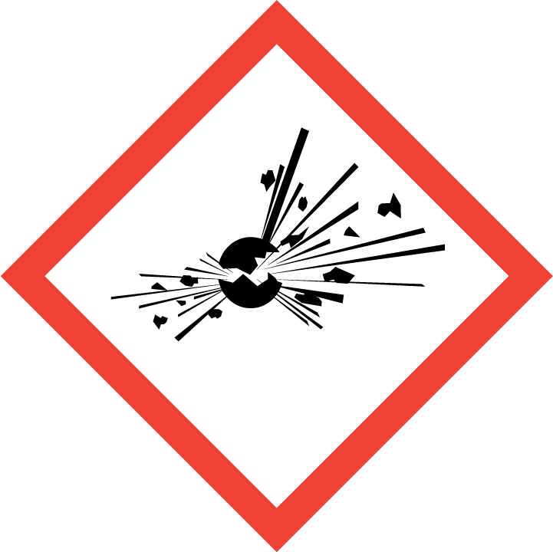 | 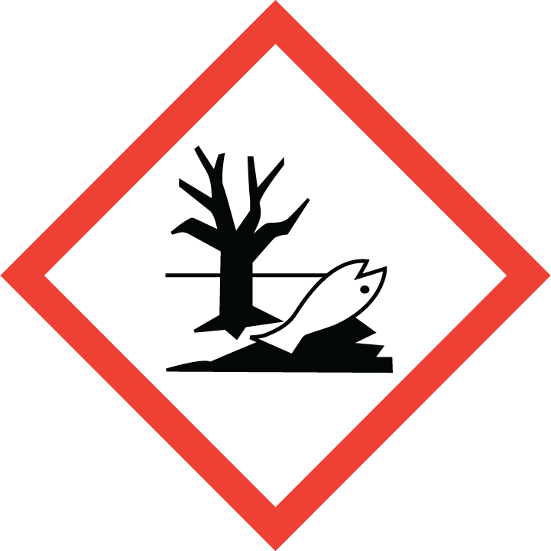 | 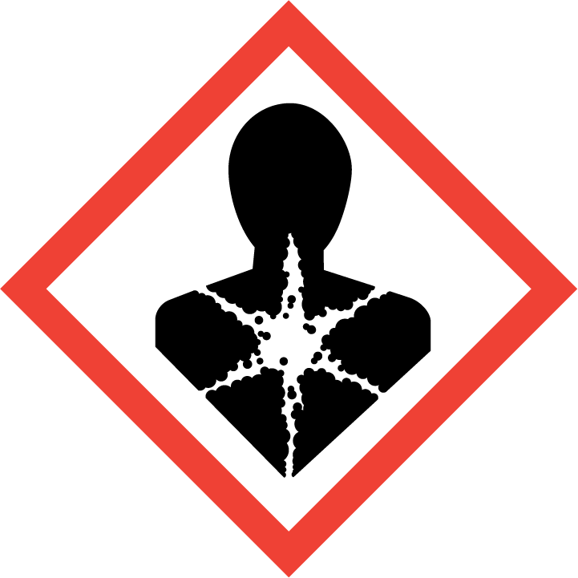
Flammable | Toxic | Harmful | Oxidising | Corrosive | Explosive | Harmful to the environment | Health Hazards i.e. respiratory sensitisation or carcinogenicity

SMOKING, EATING AND DRINKING ARE PROHIBITED IN THE WORK AREAS.
Information, Instruction and Training must be provided to all users. Young Persons, New or Expectant Mothers and other vulnerable groups must not use or be exposed to this product.

WORKPLACE EXPOSURE LIMITS (WEL’s)
The ingredient in this product with a WEL is:

Oil Mist; Mineral Oil.

IMPORTANT!
Refer to Workplace Exposure Levels information provided in the Manufacturers Safety Data and revise control measures if exposure levels likely to be reached.

ROUTE OF EXPOSURE
Skin |  | Eyes |  | Inhalation | 
Ingestion |  | Cuts/abrasions |  | Systemic

PERSONS AT RISK
User of product |  | Co workers |  | Members of the public

ROUTE OF EXPOSURE |   FIRST AID MEASURES
Eyes | Rinse immediately with plenty of water. Remove any contact lenses and open eyelids wide apart. Continue to rinse for at least 15 minutes. Get medical attention promptly if symptoms occur after washing.
Skin | Remove contaminated clothing immediately and wash skin with soap and water.
Inhalation | If spray/mist has been inhaled, proceed as follows. Move affected person to fresh air and keep warm and at rest in a position comfortable for breathing. Get medical attention if any discomfort continues.
Ingestion | Get medical attention if any discomfort continues. Do not induce vomiting.
In all cases of doubt, or if symptoms persist seek medical attention. Never give anything by mouth to an unconscious person. If unconscious, place in recovery position and seek medical advice.

PERSONAL PROTECTIVE EQUIPMENT
 |  | 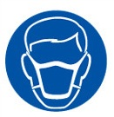 |  | 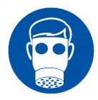 |  | 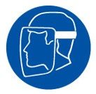
YES | YES | YES/NO |  | YES/NO | YES | YES/NO
 |  |  |  |  | 
Splash goggles. | Full suit. Boots. |  |  |  | Gloves.

HANDLING | STORAGE | TRANSPORT | DISPOSAL
Avoid spilling. Always remove oil with soap and water or skin cleaning agent, never use  organic solvents. Do not use oil-contaminated clothing or shoes, and do not put rags  moistened with oil into pockets. | Store in tightly-closed, original container in a dry, cool and well-ventilated place. | Not hazardous/ not dangerous | This material and its container must be disposed of as hazardous waste. Dispose of waste via  a licensed waste disposal contractor.

REQUIRED CONTROL MEASURES
- Users to avoid contact with skin and eyes – Use PPE.
- Ensure adequate welfare and washing facilities available and provide users with barrier and restorative creams. Take good hygiene measures.
- Ensure operatives are made aware of and understand the purpose of this assessment and MSDS, plus any health implications of using the product.
- Ensure COSHH assessments with accompanying MSDS are made available for all employees and users and for inspection and emergency purpose.
- Carry out personal exposure monitoring.
- Wash promptly if skin becomes contaminated. Wash hands at the end of each work shift and before eating, smoking and using the toilet.

FIRE PRECAUTIONS
Extinguish with foam, carbon dioxide, dry powder or water fog.

ACCIDENTAL RELEASE/SPILLAGE PROCEDURES
In case of spills, beware of slippery floors and surfaces.

Contain spillage with sand or earth. Avoid the spillage or runoff entering drains, sewers or
watercourses. The product is insoluble in water and will spread on the water surface.

MONITORING REQUIREMENTS AND HEALTH SURVEILLANCE
Health surveillance is not in place for workers exposed to this product.

